Innovation application Images Generator.
By Sergey Leontyevich Panasyuk, Panasoft
24/11/2016
Ukraine
Phone +79787642060
Email: imgenpanasoft@gmail.com
Firm Panasoft has developed a graphical application Images Generator that combines properties of the modern graphic editor with properties of computer-aided design program. Images Generator has a number of features not found in other programs. This include the following.

- The program make possible creation of beautiful images that can be used in the textile or paper industry or in other areas. Examples are shown in the figures below (pic.1, pic.2).
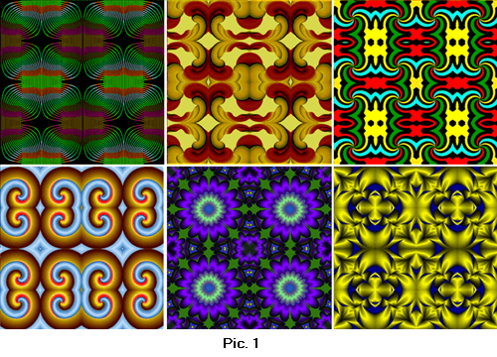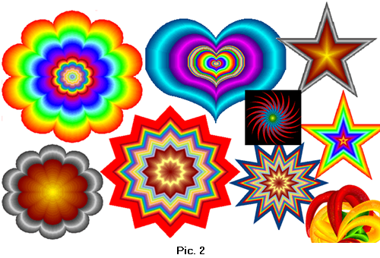
- The program allows you creation of images with use of multi-colour lines of variable width and volumetric lines (pic.3, pic.4).
- 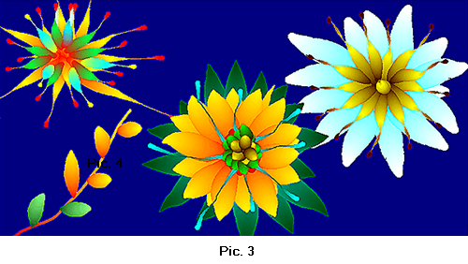
.
- Large number of built-in curves is included in Images Generator. These curves are divided into two classes that are Shapes and Mathematical Curves. Curves of type Shape are the closed non-intersecting lines.
The built-in curves can be used for obtaining of unlimited number of derivative curves. The built-in and derivative curves are used for selection of a part of the image, for use as the trajectories and for other purposes. Compatibility with system AutoCAD is provided by using of dxf files (pic.5).
- 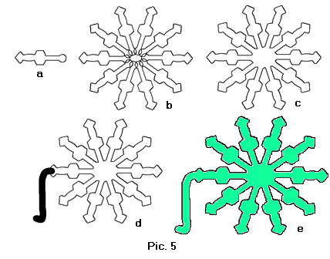
- The program allows creation of three-dimensional images that can be used for engineering and mathematical modelling (pic.6).
- 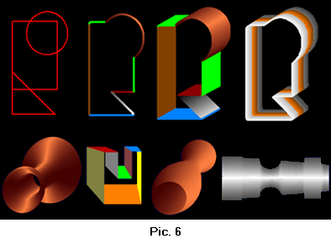
- Selection of image area based upon the colors in the image is used. Images Generator provides two modes: “In Range of Colors” and “From Background”. The first mode allows to selecting area of similar colors. The second mode allows selecting image area from a background. Border of a background is the line which points color is in the given range (pic.7).
- 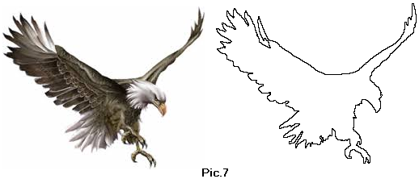
- Method of transformation of raster images provides various capabilities as creation images of faces from photos (pic.8, pic.9).
- 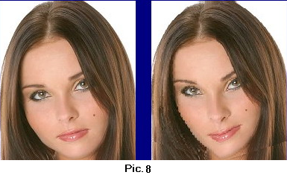
- Tooling of the Images Generator includes the convenient and effective tools for removal of unwanted blemishes, spots, scratches, creases or stains from a photo. Images Generator can be used to eliminate the sharp color transitions (pic.10).
- 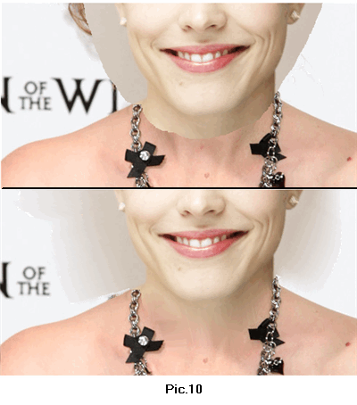
- The program provides storage of images of objects such as electrical symbols, hieroglyphs, pictures of animals and pieces of clothing. Used convenient way of a combination of these images provides simplicity of creation of different pictures – diagrams, landscapes, ads, identikits, texts, congratulatory cards and others. Images Generator may be used for fitting of clothes (pic.11).
- 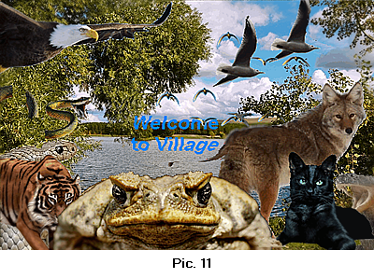
Having ample capabilities Images Generator is characterized by the small sizes and convenience of using. Such properties are provided by a number of innovative solutions. These solutions include tools Raster and Vector Brush, multi-color lines of variable width, use of various color models for selection of image parts, method of removal of image defects, raster images transformation method and others.

The scope of the program is processing photos and other images, development of Web graphics, creation of illustrations, advertisements, labels, development of various schemes and identikits, fitting of clothes and hairstyles and many more.
Images Generator pretend to be the workhorse for ordinary users and is useful addition to the toolkit of professional artists and designers. The program is mean for developing of creative abilities and can be used as developing toy for children.
Images Generator is available now and may be downloaded
Web site: http://www.imagesgenerator.com
Download: http://www.imagesgenerator.com/ImagesGeneratorSetup.zip
There are paid and free versions.

Innovation utility snap shots Generator.
with the aid of Sergey Leontyevich Panasyuk, Panasoft
24/11/2016
Ukraine
phone +79787642060
email: imgenpanasoft@gmail.com
company Panasoft has evolved a graphical application snap shots Generator that combines properties of the contemporary graphic editor with properties of computer-aided design program. pics Generator has a number of capabilities not observed in different packages. This consist of the subsequent.

· the program make feasible creation of lovely pictures that may be used within the fabric or paper enterprise or in other areas. Examples are proven inside the figures beneath (p.c.1, percent.2).

· this system allows you introduction of snap shots with use of multi-colour strains of variable width and volumetric lines (percent.3, %.four).
·
.
· large range of built-in curves is blanketed in pics Generator. those curves are divided into training that are Shapes and Mathematical Curves. Curves of kind shape are the closed non-intersecting strains.
The integrated curves can be used for acquiring of unlimited quantity of by-product curves. The built-in and by-product curves are used for selection of a part of the picture, for use because the trajectories and for different functions. Compatibility with machine AutoCAD is provided via using of dxf documents (percent.five).
·
· the program lets in creation of three-dimensional pics that can be used for engineering and mathematical modelling (percent.6).
·
· choice of photo place based totally upon the colours inside the photo is used. photographs Generator gives two modes: “In variety of colors” and “From historical past”. the first mode permits to selecting vicinity of similar shades. the second one mode lets in choosing image location from a background. Border of a background is the road which points shade is within the given range (percent.7).
·
· method of transformation of raster pics offers various skills as advent photos of faces from photographs (p.c.eight, %.nine).
·
· Tooling of the pictures Generator includes the convenient and powerful tools for elimination of unwanted blemishes, spots, scratches, creases or stains from a photograph. photos Generator can be used to remove the pointy color transitions (percent.10).
·
· the program affords storage of pix of objects which includes electric symbols, hieroglyphs, pix of animals and pieces of clothing. Used convenient manner of a aggregate of these images gives simplicity of creation of various pix – diagrams, landscapes, commercials, identikits, texts, congratulatory playing cards and others. snap shots Generator can be used for becoming of clothes (percent.eleven).
·
Having ample competencies snap shots Generator is characterised with the aid of the small sizes and comfort of using. Such residences are supplied by some of progressive solutions. those solutions consist of gear Raster and Vector Brush, multi-coloration strains of variable width, use of diverse colour models for choice of photo parts, approach of elimination of picture defects, raster images transformation approach and others.

The scope of the program is processing pictures and other pix, improvement of internet portraits, creation of illustrations, classified ads, labels, development of various schemes and identikits, becoming of clothes and hairstyles and lots of more.
photos Generator pretend to be the workhorse for normal users and is useful addition to the toolkit of expert artists and designers. the program is suggest for developing of innovative talents and may be used as developing toy for kids.
pics Generator is available now and may be downloaded
web web page: http://www.imagesgenerator.com
download: http://www.imagesgenerator.com/ImagesGeneratorSetup.zip
There are paid and unfastened versions.

